**WEBX EXP7**

|  |  |
| --- | --- |
| **Name of the Student** | **Vanshika Ambwani** |
| **Class and Roll No** | **D15A-2** |
| **DOP** |  |
| **DOS** |  |
| **Sign and Grade** |  |

**WEBX EXP7**

**AIM:** To study CRUD operations in MongoDB

**PROBLEM STATEMENT:**

1. Create a new database to storage student details of IT dept( Name, Roll no, class name) and perform the following on the database a. Insert one student details

1. Insert at once multiple student details
2. Display student for a particular class
3. Display students of specific roll no in a class
4. Change the roll no of a student
5. Delete entries of particular student

2. Create a set of RESTful endpoints using Node.js, Express, and Mongoose for handling student data operations. The endpoints should support: a. Retrieve a list of all students.

1. Retrieve details of an individual student by ID.
2. Add a new student to the database.
3. Update details of an existing student by ID.
4. Delete a student from the database by ID.

Connect the server to MongoDB using Mongoose, and store student data with attributes: name, age, and grade.

**OUTPUT:**

# 1. Create a database to store student details of IT Department

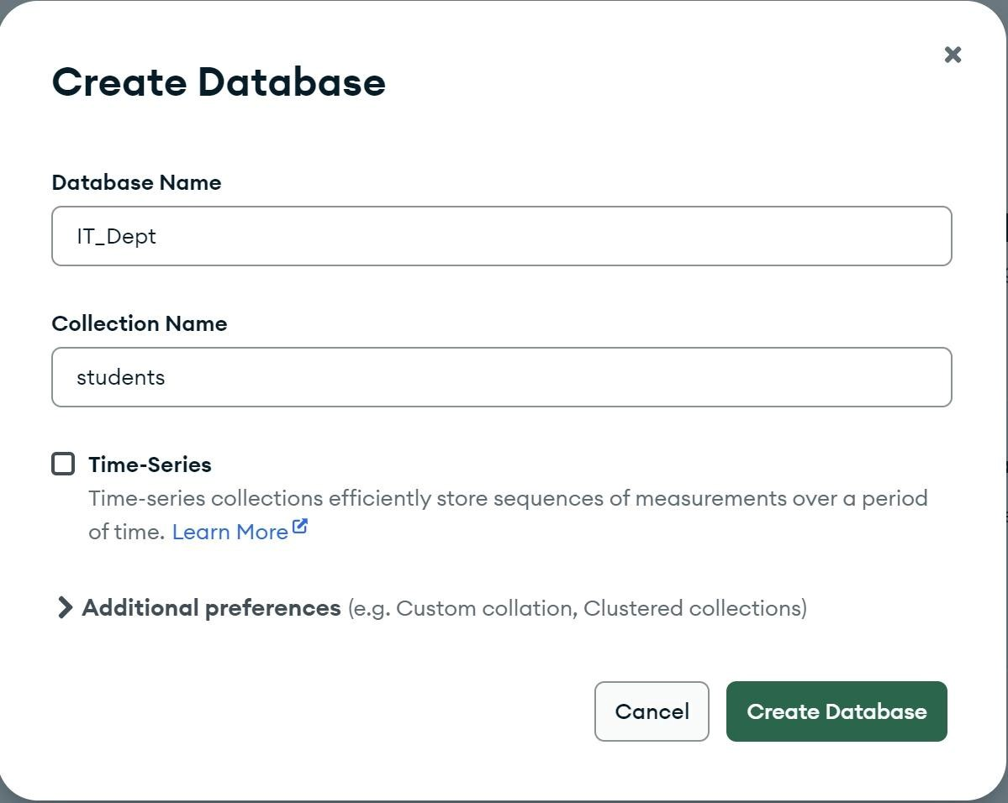

# a) Insert one Student Detail

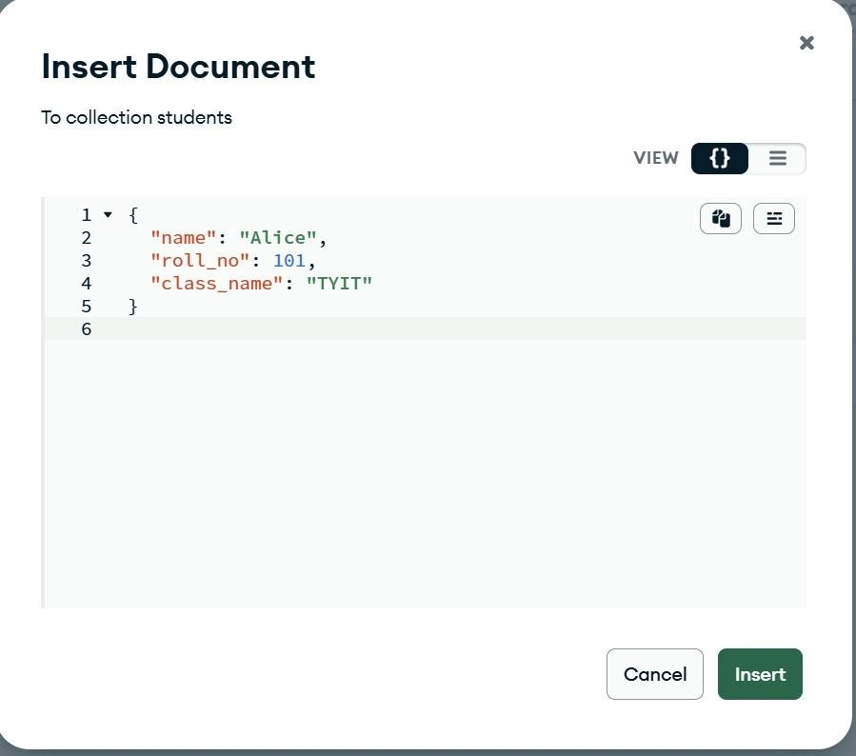

# b)Insert multiple Student Details

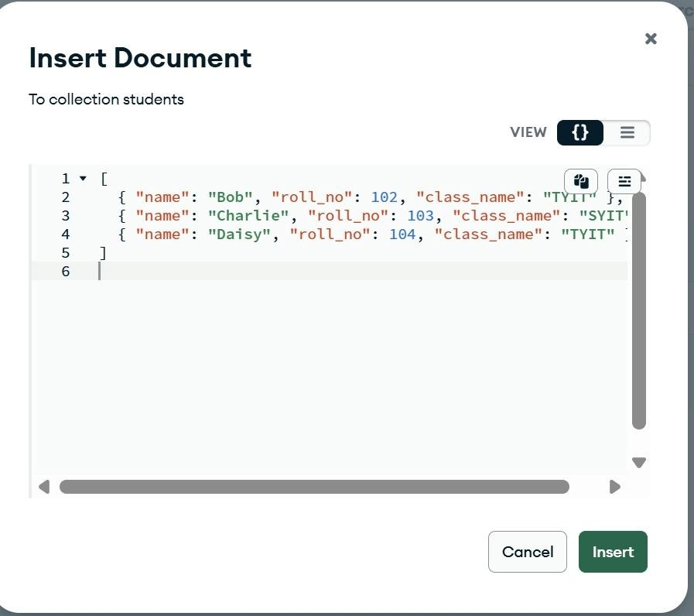

# Display Students for a Particular Class { "className": "TYIT" }

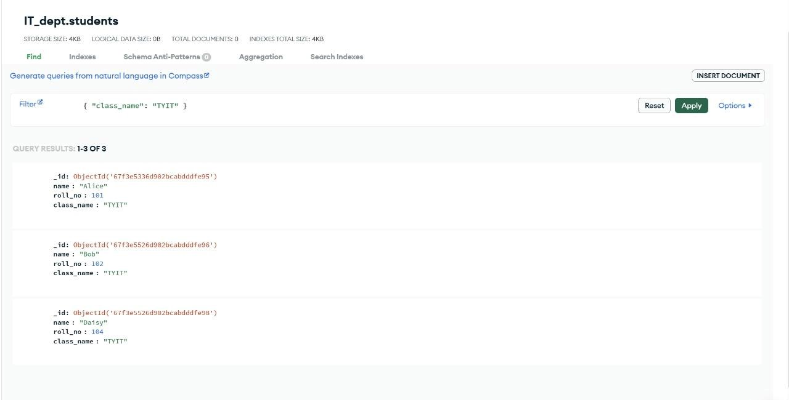

# d) Display Student of a Specific Roll Number in a Class { "className": "TYIT", "rollNo": 101 }

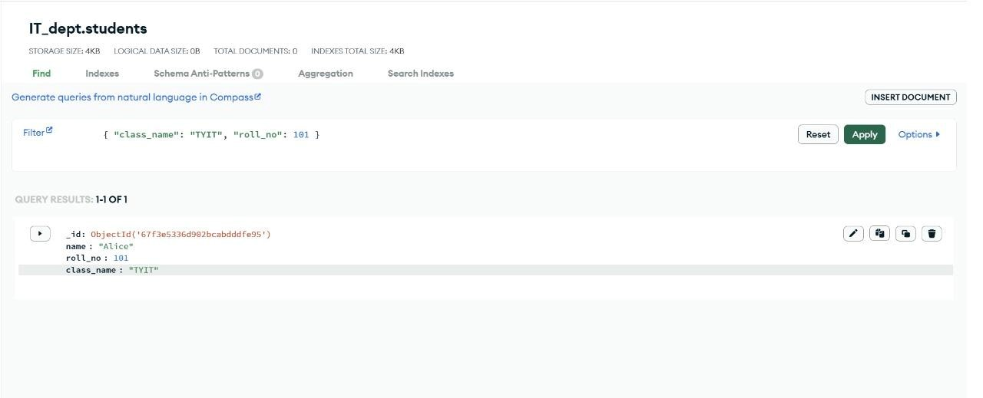

1. **Change the Roll Number of a Student Filter: { "name": "Alice" } Update:**

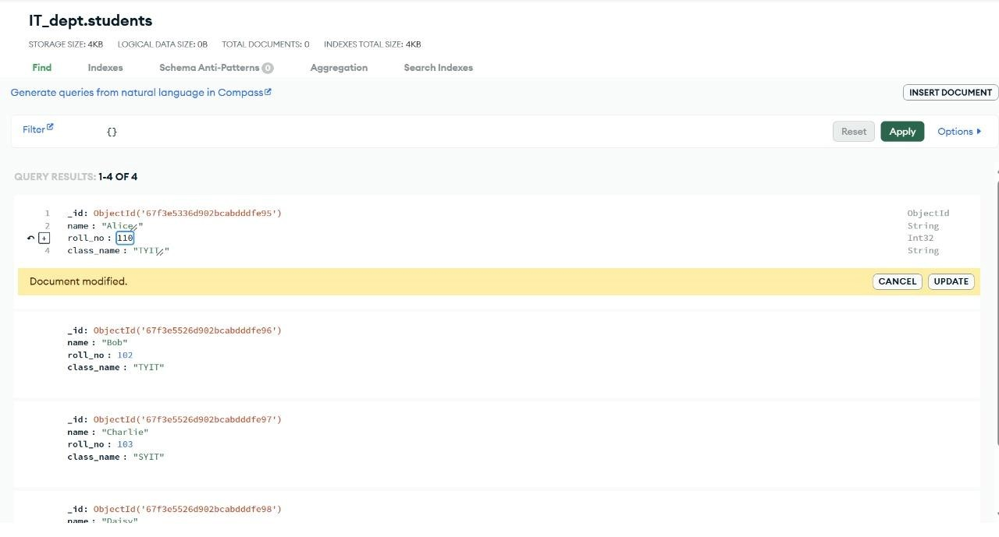

1. **Delete Entries of a Particular Student Filter:**

# { "name": "Bob" }

**Delete:**

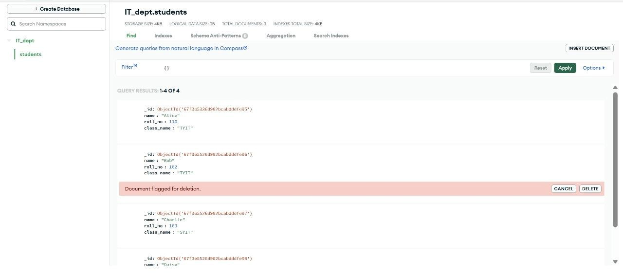

# 2. Restful api

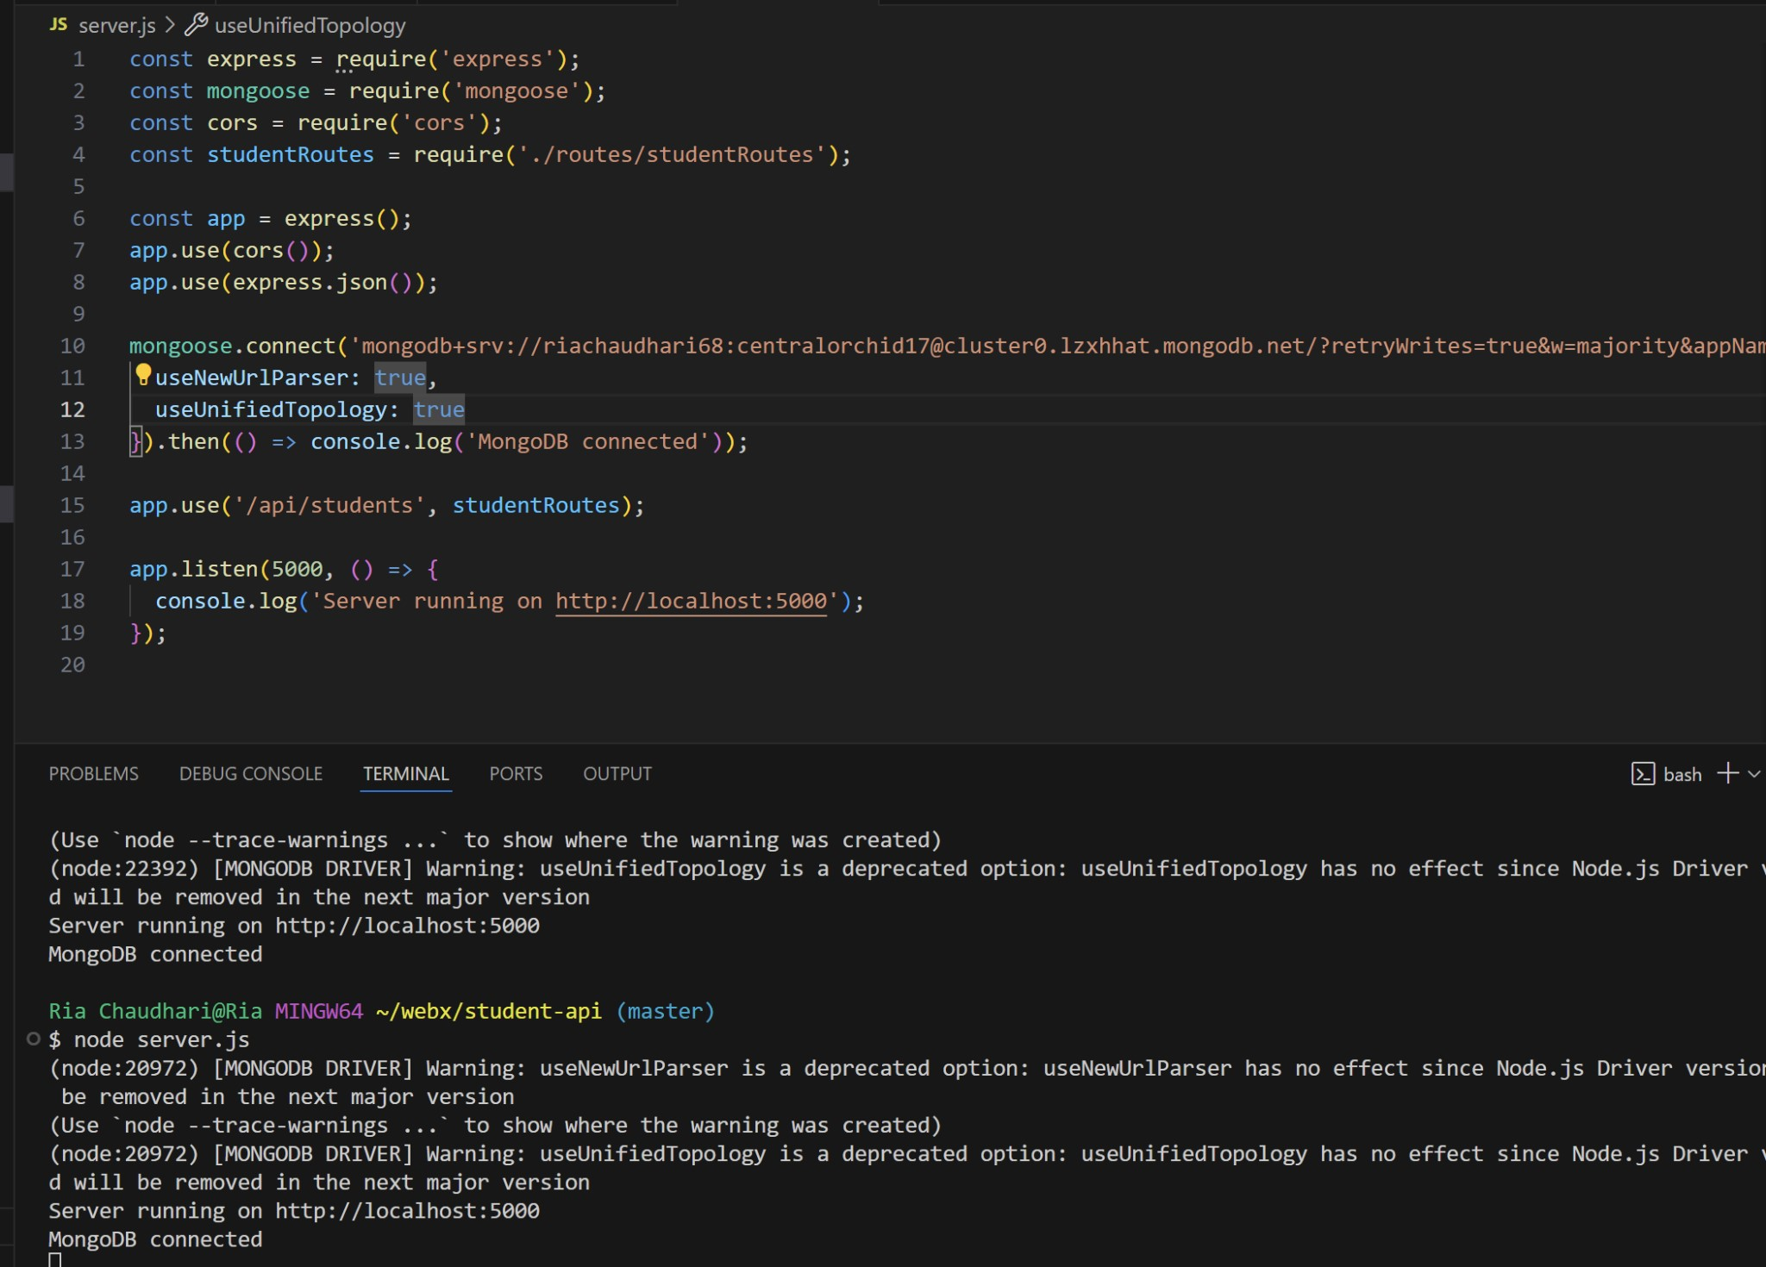

# a) Retrieve details

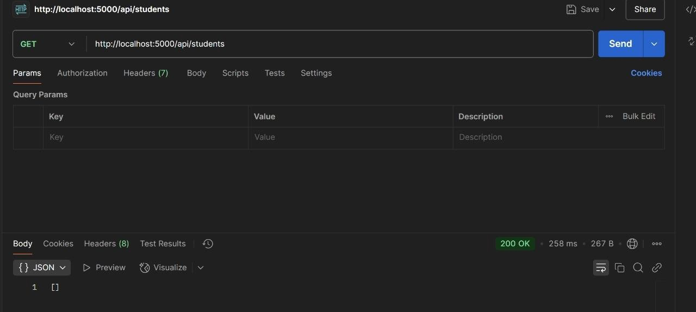

# b) Add a new student to the database

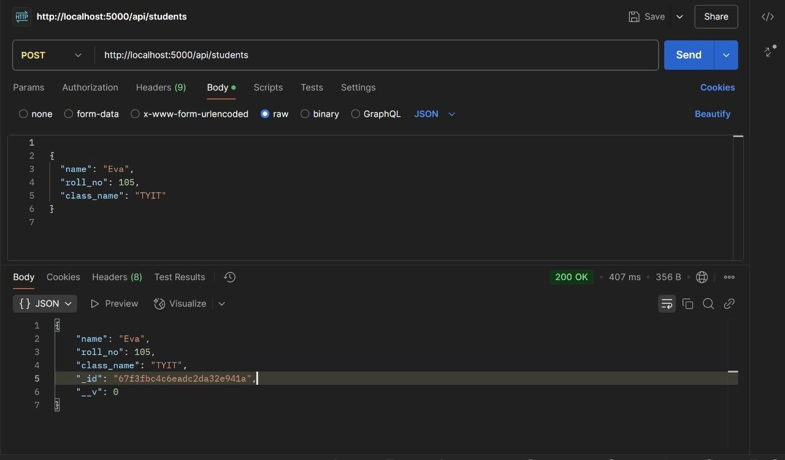

1. **Update details of an existing student by ID.**

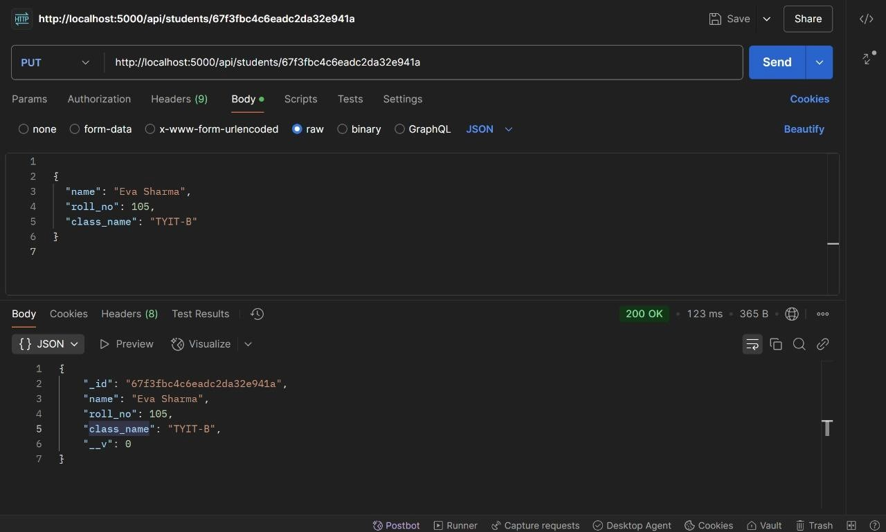

1. **Delete a student from the database by ID.**

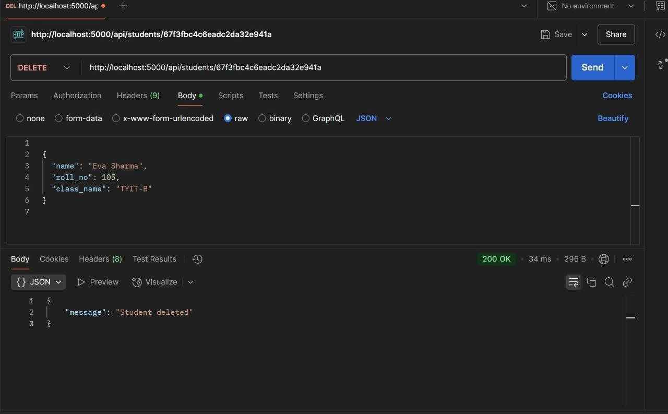

**Conclusion:**

In this experiment, we successfully performed CRUD operations in MongoDB and implemented a RESTful API using Node.js, Express, and Mongoose. We learned how to create, read, update, and delete student records both via MongoDB shell commands and API endpoints.